
Year 10 -Pathway 2

Mini Test 5.3 -Semester 2

Bivariate Data

Resources allowed: Calculator and 1 x A4 page one side

Name: ______________________ Class: ______ Time: 20 minutes Total Marks: ____/15

Show working and answers on this sheet. Show working in sufficient detail to support your answers. Incorrect answers without supporting reasoning may be allocated zero marks.

Question 1 (2 Marks)

The following survey question is biased. Write it again to improve it:
- Littering is disgusting. Do you agree or do you also litter?

The following survey question and answer set is biased. Write the question and answer set again to improve it:
- Pineapple belongs on a pizza (circle only one)

Never Yuk Gross

Question 2 (4 Marks)

For the following bivariate data please indicate which is independent (I) and dependent (D)

- Age vs Height

- Distance to my home vs Time taken to get home

- Month of the year vs Rainfall

- Depth of bath water vs Time spent filling the bath

Question 3 (3 Marks)

Lyn counted the number of rental cars crossing on the road at two-minute intervals. The table shows the data.

Time (in minutes) | Number of cars
2 | 7
4 | 8
6 | 13
8 | 19
10 | 20
12 | 24
14 | 32
16 | 37
18 | 38
20 | 41

- Which of the following scatter plots is correct?

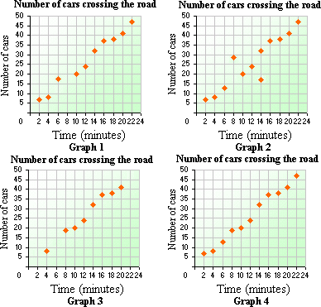

- Describe the correlation using terms such as positive, negative, strong, weak, non.

Question 4 (5, 2 – 7 Marks)

Below is the table of data regarding the cherry blossom trees in Tokyo.
Average Temp (deg C) | 1.5 | 5.8 | 2.4 | 4.0 | 4.7 | 5.4 | 3.2 | 5.0
Days into Spring | 28 | 3 | 25 | 21 | 14 | 8 | 20 | 6
- Make a scatter plot of the given data.
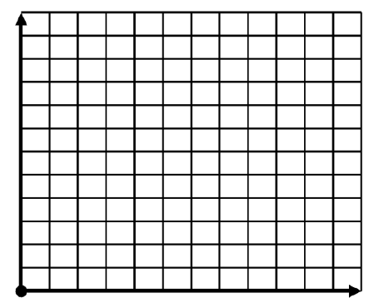
- Describe the correlation using terms such as positive, negative, strong, weak, non.

˜̴ End of Test ˜̴

